**FRUITY VEGGIE ADVENTURE: AN ANDROID GAME**

Undergraduate Project Design

Proposal Submitted to the Faculty of the

Department of Information Technology

CAVITE STATE UNIVERSITY

Cavite City Campus

In partial fulfillment

of the requirements for the degree

Bachelor of Science in Computer Science

**GLEMOR D. GABION**

**DOLPH JEMOH P. HELBANO**

**KENNARD P. LLORIN**

August 2015

**FRUITY VEGGIE ADVENTURE: AN ANDROID GAME**

**GLEMOR D. GABION**

**DOLPH JEMOH P. HELBANO**

**KENNARD P. LLORIN**

Undergraduate project design proposal presented to the faculty of the Department of Information Technology, Cavite State University-Cavite City Campus, Cavite City in partial fulfillment of the requirements for the degree of Bachelor of Science in Computer Science. Prepared under the supervision of Ms. Robyne A. Macapagal.

**INTRODUCTION**

Video games are electronic, interactive games known for their vibrant colors, sound effects, and complex graphics. These are played using a specialized electronic gaming device to manipulate images produced by a computer, a television or other display screen. Video games are designed chiefly to appeal children and adolescents. But with the wide range of game genres made available today, any user can pick a game that would suit their taste.

The website onlinedesignteacher.com states some well-known video game genres such as the Platform genre that navigates through an environment that requires timing and jumping in order to reach a destination while avoiding or disposing enemies. Role-Playing game genre are a special type of adventure game that involves a specific quest, making a character evolve to make it strong, and the careful management of inventory items for each quest. Real-Time Strategy games (RTS) refers to a time based game that centers on using resources to build units and defeat an opponent. Unlike turn-based strategy games where a player has time to carefully consider his next move without having to worry about the actions of his opponent, RTS pushes the users to defend bases, launch attacks and use resources while knowing that the opponent is doing the same thing.

Another well-known game genre is the strategy game or strategic game. It is a kind of game where the player uses autonomous decision-making that has a high significance in determining the gameplay’s outcome. Almost all strategy games require internal decision style thinking and typically very high situational awareness. The proposed study entitled “Fruity Veggie Adventure” is a strategy game that will give an interactive and challenging gameplay environment for players in their android devices.

**Importance of the Study**

The study entitled “Fruity Veggie Adventure” is an android game in 2 dimensional view that will help improve the player’s internal decision-making and strategic skills by providing situations that will require them to make careful decisions based on a given set of conditions to win each level of the game.

**Objectives of the study**

To develop a 2D strategy android game that will entertain the user and is capable of running on Android devices with versions 4.2 and above.

Specifically, the study aims to:

1. design a user-friendly 2D graphical user interface;
2. create a challenging and interesting gameplay environment;
3. create the game using UNITY 3D and Adobe Photoshop CS6 for the Graphical Design.
4. test and improve the system; and
5. evaluate the system using ISO 9126.

**Time and Place of the Study**

The study is being conducted at Cavite State University – Cavite City Campus, from July 2015 to October 2015.

**Scope and Limitations of the Study**

The game “Fruity Veggie Adventure” is a 2D strategy game where the main characters are heroic fruits and vegetables that have elemental attributes fighting insects and pests that also possess elemental attributes. The goal of each stage is to keep the insects from reaching the other end of the stage area and keeping the life of the player from reaching 0. When an insect or pest reaches the other end, one life is deducted from the player. The player’s initial life starts at 5. When the player’s life reaches 0, the game will be over.

The game’s storyline starts by introducing the two worlds namely Fruity-Veggie World which is ruled by King Guava and the Insect World which is reigned by the Insect Queen. One day, the King’s wife, Queen Bitter Gourd, discovered that she cannot give birth. Because of this, she became depressed, she cried, and ran away. She stopped by a faraway lake and here, she met the Insect Queen who told her that she can grant her the ability to give birth. Only if she will come to the Insect Queen’s place. As soon as she accepted, the Insect Queen suddenly attacked and hypnotized Queen Bitter Gourd and is now using her to lead the army of pests and insects to attack Fruity-Veggie World. After this, the gameplay for the first stage of the first level will start with King Guava guiding the user on how to play the game. He will instruct the user to place the Carrot hero to one of the potholes and observe how it will attack the incoming pests. The game ends when the user defeats the Insect Queen at the last level of Stage 10. This is to avenge the death of Queen Bitter Gourd who is killed by the Insect Queen at the last level of Stage 9. The Insect Queen’s identity is revealed as Angela, the past lover of King Guava. Angela tricked Queen Bitter Gourd because she had envied the Queen for being loved by King   
Guava. The scene ends when Angela tries to attack the King but the Veggie police instantly comes and arrests Angela. The ending scene shows that the King returned to Fruity-Veggie World, imprisoned Angela, gave Queen Bitter Gourd a decent burial, and peace is restored to Fruity-Veggie World once again. The story line has a voice over or narration.

The game is for single use and is composed of different modules like Map, Library, and Shop. The Map module contains 10 stages each containing 3 levels that the user will venture through the whole game. After choosing the first stage and the first level, the user can now play the game. Another level is opened when the previous level is cleared and another stage is accessible when all the three levels of a previous stage are completed. Each stage is classified into three difficulties/modes which are Easy (Stage 1-4), Medium (Stage 5-7), and Hard (Stage 8-10). The user can play Medium difficulty after finishing Easy and Hard mode is available after finishing Medium. At the end of each stage, the user has to defeat a boss. The Library module contains information of each character, and insects that the user may encounter. For example, the user encountered the pest worm, he can view the worm’s information like Speed, Hit Points (HP), which mode it appeared, pathway, and a brief description about itself. The Shop module has 3 tabs, the Upgrade hero, Boosters, and Special equipment. Upgrade hero makes the heroes stronger, by spending money (Peso) to increase the hero’s damage, HP and/or attack speed. The Boosters tab helps the users if they’re finding it difficult to finish a level. The game has a total of 4 boosters. The Life potion that adds extra lives to the player, but does not exceed the max life of a player. The Hero potion that heals the hero, the Water booster that adds extra water, and Poison that reduces enemy HP in 10 seconds. The Poison can be used one at a time, and can be reused after the defined 10 second time interval. Each booster has a maximum quantity of 3. These items go into the player’s inventory which they can use at the actual battle. The Special Equipment tab will only appear if the user gets to Medium mode. These equipment can transform a hero into a stronger/upgraded version of itself with higher strengths, damage, and/or a new way of attacking. When an upgraded hero is unlocked, the player can still use both the original hero and the upgraded hero in battle. Each stage on the game contains one background and stage area. When the user loses on a level, he is redirected into the map or the level select. If he wishes to restart the level, he will also be redirected to the level select.

Each Hero and Insect has one elemental attribute namely Fire, Air, or Water. Water defeats Fire, Fire defeats Air, and Air defeats Water. When a hero of Fire element attacks an insect of Air element, it will deal a greater damage compared if it will attack an insect with the same element of Fire. Here, the damage is only normal. If Fire will attack its weakness which is the Water element, the damage dealt will be lesser and smaller than normal. The starting wave for the first level is 3 and is incremented by 1 for each progressing level. The game is played by placing the heroes in the potholes where they will attack an incoming insect when it is inside their range. If the user wants to remove a fruit/vegetable hero which is already planted, he can click on that hero and choose Remove. Each hero removed gives a refund of 40 percent. At the start of each level, the arrival of the insects will only start if the user will press the Next Wave button. But once the battle starts and another wave is coming, the user can press the button to start the wave immediately or if he has to prepare, he is given a limited time before the arrival of the next insects. Each fruit/vegetable costs Water which the user is given a fair supply at the start of each game. Users can also obtain Water by defeating insects. The number of insects and the insects itself contained in a wave is fixed but the number varies from level to level. Each wave of insects has one specific element which is randomized too. The players can see what type of element the next wave of insects will have by looking at the indicator at the lower left of the gameplay screen. This indicator will also tell if the insect’s pathway is land, air or both to carefully plan what hero is suitable to use. The user can press the 2x gameplay speed button for faster battle outcomes. There is also a Pause button, when pressed, the options Restart Level, Resume, Back to Map, Turn Sounds and Vibrations on/off are available. The Sounds and Music effects of the game are toggled as one. When the user chooses to go back to the map, his/her progress on the current level will be lost. At the end of each level, a reasonable amount of Peso is given to the player to purchase items at the shop or upgrade their heroes. When the player has more than 3 characters, He will be given a window to select up to 5 heroes that he can use on gameplay.

Once a level is cleared without any lives deducted, that level will have a text indicated “Perfect”. If not, the text indicates “Cleared”. If a level is finished perfectly, greater rewards await at the end of the level. When a level is “Cleared” the user receives money depending on the percentage of how many lives he has left. If the player wants to go back to a level, in case that he wants to perfect that level, the money that he receives will depend on the percent of lives that he had to complete since his last play on that stage. If the user failed to complete the remaining percent that he had to achieve, He will receive only 5 percent for that level’s reward money. If the player goes back and finishes a level that is already in “Perfect” status, He will receive a total of 5 percent of the reward money for that level. Once a level is finished and that level rewards an item, the user cannot obtain the same item again from that level as a reward. When the player finishes a level, the game automatically saves. If the player closes the game in the middle of his/her gameplay, their progress won’t be saved. In this case, what will be saved are the items they bought in the shop.

There are 9 heroes in the game namely Carrot, Banana, Watermelon, Orange, Rambutan, Leek, Mushroom, Onion, and Coconut. There corresponding upgraded versions are the following: Carrot Cannon, Healing Banana, Blaster Melon, Orange Saucer, Rambu-stun, Laser Leek, Necro-Mushroom, and Mega-Onion. There are 10 pests/insects that they will fight: Ants, Fly, Grasshopper, Caterpillar, Stink Bug, Mole Cricket, Snail, Cicada, Beetles, and Locusts. The strength of these insects increase as the user gets to higher levels. On Hard mode, the insects have the ability to attack the heroes and kill them, if their HP drops to 0. That’s why some heroes have the ability to heal their co-heroes.

To add, the game doesn’t require any internet connection to operate and real money to buy the items that can be seen on the shop. The game can only be played in Landscape left view. The user can also turn the sound and vibration on/off.

The game will be tested if compatible for cross-platform systems to assure compatibility. Cellphones like Samsung will also become part of the testing procedures. The Android OS jellybean, kitkat and lollipop are the testing targets to see if the application/game will run on these said operating systems. Players aged 10 – 17 years old are the target users of the game.

**Conceptual Framework**

Input

Process

Output

**Knowledge Requirements**

* Android Phone
* UNITY3D
* Graphic Design Knowledge
* Emulator
* Evaluation System
* Adobe PS6

**Software Requirements**

* Windows XP or 7 for creation
* C#
* Android OS

**Hardware Requirements**

* Computer
* Android Phone

System Design

System Development

System Testing and Improvement

Fruity Veggie Defense

Evaluation

**Figure 1.** Conceptual Framework of Fruity Veggie Adventure

**Operational Definition of Terms**

**2 Dimensional.**Having only two dimensions, especially length and width.

**Hitpoints.** Also known as HP or health represents the amount of damage a player or monster can withstand until he/she dies. This is known as death, which happens when their hitpoints reaches zero.

**Pathway.** A route, a way where the monsters pass and indicates if they are a flying or walking insect.

**Cross-platform.** Able to be used on different types of computers or with different software packages.

**Landscape.** In photography and digital photography, landscape mode is a function of the digital camera that is used when you are taking photos of a scene, not a single object.

**CHAPTER II**

**REVIEW OF RELATED LITERATURE**

In this section, the researchers presented the related literature and studies. Through this review, it could provide help to the developers to properly develop the application.

**Mobile OS**

According to techopedia.com a mobile operating system (mobile OS) is an OS built exclusively for a mobile device, such as a smartphone, personal digital assistant (PDA), tablet or other embedded mobile OS. Popular mobile operating systems are Android, Symbian, iOS, BlackBerry OS and Windows Mobile.

A mobile OS is responsible for identifying and defining mobile device features and functions, including keypads, application synchronization, email, thumbwheel and text messaging. A mobile OS is similar to a standard OS (like Windows, Linux, and Mac) but is relatively simple and light and primarily manages the wireless variations of local and broadband connections, mobile multimedia and various input methods.

**Symbian OS**

According to mobileburn.com the Symbian OS is the operating system developed and sold by Symbian Ltd. The OS is used primarily by Nokia with its S60 user interface and by Sony Ericsson with its UIQ user interface, but the Symbian OS is also used by a number of Japanese mobile phone manufacturers for handsets sold inside of Japan. With Nokia's acquisition of Symbian, the Symbian OS is to be spun off into as an open source product offered by the newly formed Symbian Foundation.

**iOS**

According to ipad.about.com, iOS is Apple's mobile operating system used to run the popular iPhone, iPad and iPod Touch devices. Formerly known as the iPhone OS, there are over 900,000 iOS applications available for download in the Apple app store, the most popular app store of any mobile device. iOS utilizes a multi-touch interface

where simple gestures are used to operate the device, like swiping your finger across the screen to move to the next page or pinching your fingers to zoom out.

**Windows Mobile**

According to webopedia.com the Windows Mobile OS is a mobile operating system for smartphones and mobile devices from Microsoft based on the Windows CE kernel and designed to look and operate similar to desktop versions of Microsoft Windows. Windows Mobile competes in the mobile OS market with Apple's iOS, Google's Android, BlackBerry OS, Symbian and others. Windows Mobile first debuted as the operating system for Microsoft's original personal digital assistant (PDA) device, the Pocket PC, in 2000. Later releases included Windows Mobile 2003 ("Ozone"), Windows Mobile 5 ("Magento") and Windows Mobile 6 ("Crossbow"). Windows Mobile has largely been supplanted by Windows Phone 7, although Microsoft did release in 2011 Windows Embedded Handheld 6.5, a mobile OS compatible with Windows Mobile 6.5 that's designed for enterprise mobile and handheld computing devices.

**Android OS**

According to techopedia.com the development of the Android OS was a result of the consortium of the initial members of the Open Handset Alliance (OHA) such as Google, HTC, Dell, Intel, Motorola, Qualcomm, Texas Instruments, Samsung, LG, T-Mobile, Nvidia, and Wind River Systems back in November of 2007. The OHA is a business alliance of hardware, software and telecom companies dedicated to advance the cause of open sourcing for mobile phones.

Based on the modified version of the Linux kernel version 2.6, the Android code was released by Google under the Apache license which is also a free software and open source license.

The Android OS consists of numerous Java applications and Java core libraries running under the Java-based object oriented application framework and the Dalvik Virtual Machine (VM). Dalvik is integral for the Android to run in mobile devices as these systems are constrained in terms of processor speed and memory.

As for multimedia support, the Android OS can back 2D and 3D graphics, common audio and video formats. It may also support multi-touch input (depending on device) and carries in its browser Google Chrome’s V8 Javascript runtime.

The version history of the Android mobile operating system began with the release of the Android [beta](https://en.wikipedia.org/wiki/Beta_(software)) in November 2007. The first commercial version, Android 1.0, was released in September 2008. Android is under ongoing development by Google and the Open Handset Alliance (OHA), and has seen a number of [updates](https://en.wikipedia.org/wiki/Patch_(computing)) to its base operating system since its initial release.

The most recent major Android update is Android 5.0 "Lollipop", which was released on November 3, 2014. Since April 2009, Android versions have been developed under a confectionery-themed code name and released in alphabetical order, beginning with Android 1.5 "Cupcake"; the earlier versions 1.0 and 1.1 were not released under specific code names: Cupcake(1.5), Donut(1.6), Eclair(2.0–2.1), Froyo(2.2–2.2.3), Gingerbread(2.3–2.3.7), Honeycomb(3.0–3.2.6), Ice Cream Sandwich(4.0–4.0.4), Jelly Bean(4.1–4.3.1), [KitKat](https://en.wikipedia.org/wiki/Android_KitKat)(4.4–4.4.4, 4.4W–4.4W.2) and Lollipop(5.0–5.1.1).

**Android Phones**

According to techopedia.com the Android cell phone is a cell phone running the Android OS. A typical Android cell phone is a smartphone with a touch screen interface, multiple connectivity options, Internet browsing capabilities, support for video playback and a camera.

The term Android cell phone is actually a generic term. Unlike iPhone phones or BlackBerry phones, which always refer to phones manufactured by Apple and RIM (Research In Motion) respectively, Android phones may refer to a wide selection of phones from different manufacturers, including Motorola, HTC, Lenovo, LG, Samsung and Sony Ericsson.

Some of the Android cell phone models gaining a lot of public attention include Motorola Droid X, HTC Dream, Google Nexus One and Samsung Galaxy. Android sales have been showing the fastest growth among smart phones since the first Android phone was released in 2008. The first Android phone was the HTC Dream, also called the T-Mobile G1.

Android cell phone applications can be downloaded from the Android Market.

**Android Application Development**

According to Wikipedia.org android software development is the process by which new applications are created for the Android operating system. Applications are usually developed in Java programming language using the Android software development kit (SDK), but other development environments are also available.

As of July 2013, more than one million applications have been developed for Android, with over 25 billion downloads. A June 2011 research indicated that over 67% of mobile developers used the platform, at the time of publication. In Q2 2012, around 105 million units of Android smartphones were shipped which acquires a total share of 68% in overall smartphones sale till Q2 2012.

**Programming Language**

According to techopedia.com android apps are written in the Java programming language and use Java core libraries. They are first compiled to Dalvik executables to run on the Dalvik virtual machine, which is a virtual machine specially designed for mobile devices.

Developers may download the Android software development kit (SDK) from the Android website. The SDK includes tools, sample code and relevant documents for creating Android apps.

Novice developers who simply want to play around with Android programming can make use of the App Inventor. Using this online application, a user can construct an Android app as if putting together pieces of a puzzle.

**Emulator**

According to developer.android.com, the Android SDK includes a mobile device emulator — a virtual mobile device that runs on your computer. The emulator lets you develop and test Android applications without using a physical device.

**Developing Android Games using Unity**

According to docs.unity3d.com building games for a device running Android OS requires an approach similar to that for iOS development. However, the hardware is not completely standardized across all devices, and this raises issues that don’t occur in iOS development. There are some feature differences in the Android version of Unity just as there are with the iOS version.

**Set up the Android SDK**

According to androidauthority.com an Android SDK is a software development kit that enables developers to create applications for the Android platform. The Android SDK includes sample projects with source code, development tools, an emulator, and required libraries to build Android applications. Once the SDK is installed, you need to add the Android 5.01 (API level 21) package to it. Run the SDK Manager and use it to download the API level 21 packages (it should all be selected by default)

**Setup your device for testing**

According to docs.unity3d.com this can setup be tricky, especially under Windows based systems where drivers tend to be a problem. Also, your device may come with additional information or specific drivers from the manufacturer. For Windows: If the Android device is automatically recognized by the system you still might need to update the drivers with the ones that came with the Android SDK. This is done through the Windows Device Manager. Note: Don’t forget to turn on “USB Debugging” on your device. Go to Settings -> Developer options, then enable USB debugging. As of Android Jelly Bean 4.2 the Developer options are hidden by default. To enable them tap on Settings -> About Phone -> Build Version multiple times. Then you will be able to access the Settings -> Developer options.

To test that everything is set up, plugin in your device, open a cmd prompt and run the following commands:

cd \android-sdk\platform-tools

adb devices

Your plugged in device should be listed. If not check your device as it may be prompting you to authorize your PC.

**Add the Android SDK path to Unity**

According to docs.unity3d.com the first time you build a project for Android (or if Unity later fails to locate the SDK) you will be asked to locate the folder where you installed the Android SDK (you should select the root folder of the SDK installation). The location of the Android SDK can also be changed in the editor by selecting Unity > Preferences from the menu and then clicking on External Tools in the preferences window.

**Game Genres**

Onlinedesignteacher.com lists some of the well known Computer Game Genres that most games fall within a particular category or genre. Some bridge different gaming styles and, thus, could appear under more than one category simultaneously. Shooter: One of the oldest genres of video game is the classic shooter. It has roots in the early 60s with Steve Russell's Spacewar! Shooters are games that require the player to blow away enemies or objects in order to survive and continue game play. Classic examples include Defender, Galaga, R-Type, Phoenix, Space Invaders, Tempest, Xevious, and Zaxxon. First-Person-Shooter (or FPS): This is an example of a sub-genre that has grown enough to become its own genre. In fact, because of the prevalence of these games, many people use the term "shooter" to refer to first-person-shooters. These games are real time fast-paced action games in which the player navigates an environment from a first-person perspective and, usually, blows everything and everyone away whenever possible. Though this is a relatively new genre (since the early 1990s), it has grown in popularity. Examples of first-person-shooter franchises include Wolfenstein 3D, Doom, Duke Nukem 3D, Descent, Marathon, GoldenEye, Halo, Quake, and Time Splitters. Adventure: Another of the first video game genres, especially from the computer platforms, was the adventure game. These were initially text-based games like Will Crowther's Collossal Cave and the original Zork games. There has always been a strong following for this genre because of the challenge of puzzle-solving and the general lack of violence. This has also made it popular for many non-traditional gaming demographics. In recent years, LucasArts and Cyan have been known for their contributions to the adventure genre. Other examples of adventure franchises include Gabriel Knight, Indiana Jones, Maniac Mansion, Monkey Island, Myst, Police Quest, and Syberia. Platform: It is believed that the platform genre began in 1981 with the release of the games Donkey Kong and Space Panic. Games within this genre are usually identified by navigating environments that require timing and jumping in order to reach a destination while avoiding and/or disposing of enemies. Many of these, like Donkey Kong, have a series of screens, each with its own individual pattern of challenges. As companies began to develop platform games for home consoles and computers instead of arcade machines (i.e. Super Mario Bros for the Famicom and Nintendo Entertainment system), they took advantage of the evolving processors and greater memory capacity by transcending individual screens and utilizing actively sidescrolling worlds. Role-Playing Games (RPGs): Evolving from pen-and-paper games like Dungeons and Dragons, RPGs are a special type of adventure game that usually incorporate three major elements: 1) a specific quest, 2) a process for evolving a character through experience to improve his/her ability to handle deadlier foes, 3) the careful acquisition and management if inventory items for the quest (i.e., weapons, armor, healing items, food, and tools). Although these games still have many variations and appearances. Puzzle: In many ways, puzzle video games are not dissimilar from traditional puzzles. What they offer are unique environments that are not as easily introduced in one's living room. For example, Wetrix enables the player to build up a series of walls that would be able to contain a deluge of water when it falls. Successful completion of a level involves capturing enough water. Other examples include Tetris, Intelligent Qube, Puzzle Bobble, Puyo Puyo, Devil Dice, and Mercury. Simulations: By their nature, simulations are attempts to accurately re-create an experience. These can be in the form of management simulations like SimCity and Theme Hospital, or more hands on like MicroSoft Flight Simulator or Gran Turismo. Vehicle simulation: Vehicle simulation games are a genre of video games which attempt to provide the player with a realistic interpretation of operating various kinds of vehicles. - Life Simulation: Social simulation games base their game play on the social interaction between multiple artificial lives. The most famous example from this genre is Will Wright's The Sims.

**Plants vs. Zombies**

Plants vs. Zombies is a tower defense video game developed and originally published by PopCap Games for Microsoft Windows and OS X. The game involves a homeowner using a variety of different plants to prevent an army of zombies from entering their house and "eating their brains". It was first released on May 5, 2009, and made available on Steam on the same day. A version for iOS was released in February 2010, and an HD version for the iPad. An extended Xbox Live Arcade version introducing new gameplay modes and features was released on September 8, 2010. PopCap released a Nintendo DS version on January 18, 2011 with content unique to the platform. The PlayStation 3 version was released in February 2011 also with added new co-op and versus modes found in the Xbox 360 version. An Android version of the game was released on May 31, 2011 on the Amazon Appstore, while it was also released to the Android Market (now Google Play) on December 14, 2011. On February 16, 2012, a version was released for BlackBerry PlayBook. Later, a BlackBerry smartphone version of the game was released on January 2013 following the launch of BlackBerry 10. Furthermore, both the original Windows and Mac version of the game have been re-released with additional content in a Game of the Year version. In January, 2015, a free ad-supported version of the game was released for iOS.

The game received a positive response from critics, and was nominated for multiple Interactive Achievement Awards, alongside receiving praise for its musical score. A sequel, Plants vs. Zombies 2: It's About Time, was released on August 15, 2013 for iOS.

**Strategy Game**

A strategy game or strategic game is a game (e.g. video or board game) in which the player’s [uncoerced](https://en.m.wikipedia.org/wiki/Coercion) and often autonomous decision-making skills have a high significance in determining the outcome. Almost all strategy games require internal decision tree style thinking, and typically very high situational awareness.

**CHAPTER III**

**METHODOLOGY**

This chapter discusses the software development and techniques used by the developers to develop the project study.

**Project Design**

This section contains the context diagram, and system flow chart. This can give an idea of how the system will be made.

*Context Diagram*

**Legend:**

**N –** Name

**C** – Controls

**UR** – User Record

N, C

UR

User

User

**Figure 2.** Context Diagram of Fruity Veggie Adventure

As illustrated in Figure 2, the data flow starts when the user inputs his/her name through a control device such as an android phone then the game will record the user’s gameplay and output it so the user can load his/her gameplay.

*System Flowchart*

Start

Design Level

Conceptualization

Bugs Found?

Build resource files

Feedback

Play Testing

Build Level

Game play Issues found?

Yes

A

No

No

Is Final Level?

Yes

Yes

No

**Figure 3.1.** Development process of Fruity Veggie Adventure

Yes

No

A

Bundle All Finished Levels into one package

Bug Testing

Bugs Found?

Release Beta

End

**Figure 3.2.** Development process of Fruity Veggie Adventure (Continuation)

As illustrated in figure 3 the game will start with the conceptualization of the design and concept then will make a level that corresponds and enforces the chosen design, then the developers will begin making and gathering the necessary resources to build the level. After that a test level is built and will undergo play testing, the developers will then collect feedback from the play testers, if the current build contains a bug it will be fixed and the build will be resent for another play test, if the current build does not contain a bug but was found lacking in content or in not meeting the required/desired challenging factor, then the level will be redesigned this time with the help of the tester’s feedback, then repetitively continue this process until the final level is made. After that, compile the entire game into one package, do a bug test to make sure nothing went wrong during compilation and release the beta.

**Data collection**

This section will contain the operating and testing procedure

*Operation and testing*

1. Install the game
2. Play the game
   1. Start a new game
      1. Test all functions
      2. Test auto-saving feature
3. Load game
4. Check loaded game
5. Uninstall the game

**Data Analysis**

This section describes how data were analyzed to find answers/solutions to the research problems.

**Evaluation Procedure**

The evaluation for prototype has the following criteria: Functionality, Reliability, Usability, Efficiency, Maintainability, and Portability. The following are the steps carried out during evaluations:

1. Evaluation forms will be distributed to the testers.
2. The developers will demonstrate how to operate the system and will explain some of its functions.
3. The performance of the system will be rated by the evaluators or respondents based on the Likert scale as shown in Table 1. The respondent will choose from a scale of 1-5 with 5 being the highest which means excellent and 1 being the lowest which needs improvement.
4. Evaluation results will be tabulated to compute for the mean of each criterion and the overall mean of the criteria evaluation forms.
5. The Developers will use the Rating scale for interpreting the Evaluation results as shown in table 2 to interpret the result of the evaluation.

**Table 1.** Likert Scale

|  |  |
| --- | --- |
| **Numerical Scale** | **Interpretation** |
| 5 | Excellent |
| 4 | Very Good |
| 3 | Good |
| 2 | Fair |
| 1 | Poor |

**Table 2.** Descriptive evaluation of the mean

|  |  |
| --- | --- |
| **Numerical Scale** | **Interpretation** |
| 4.51 - 5.00 | Excellent |
| 3.51 - 4.50 | Very Good |
| 2.51 - 3.50 | Good |
| 1.51 - 2.50 | Fair |
| 1.00 - 1.50 | Poor |

**RESULTS AND DISCUSSION**

This chapter includes project description and structure, test results, capabilities and limitation and evaluation of the system.

**Project Description and Structure**

The Fruity Veggie Adventure is an android game that is specifically designed to:

Features:

1. To entertain the user;

Figure 3 shows the main menu of the game. It has the play and settings button that goes to another module of the game.

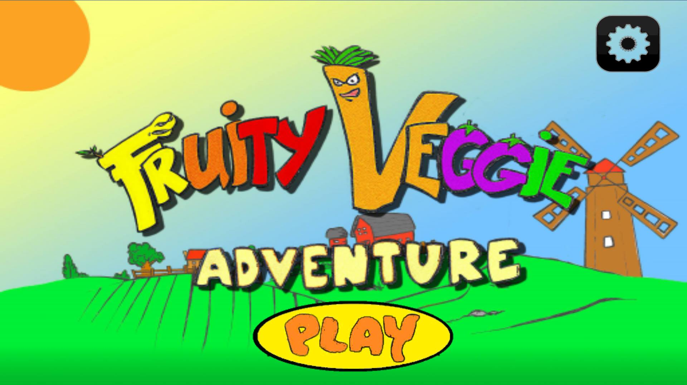

Figure 3. Main menu

Figure 4 shows the map of the game; in this module the user can access the shop, achievements and library module. The user can also select in which world does he/she wants to play.

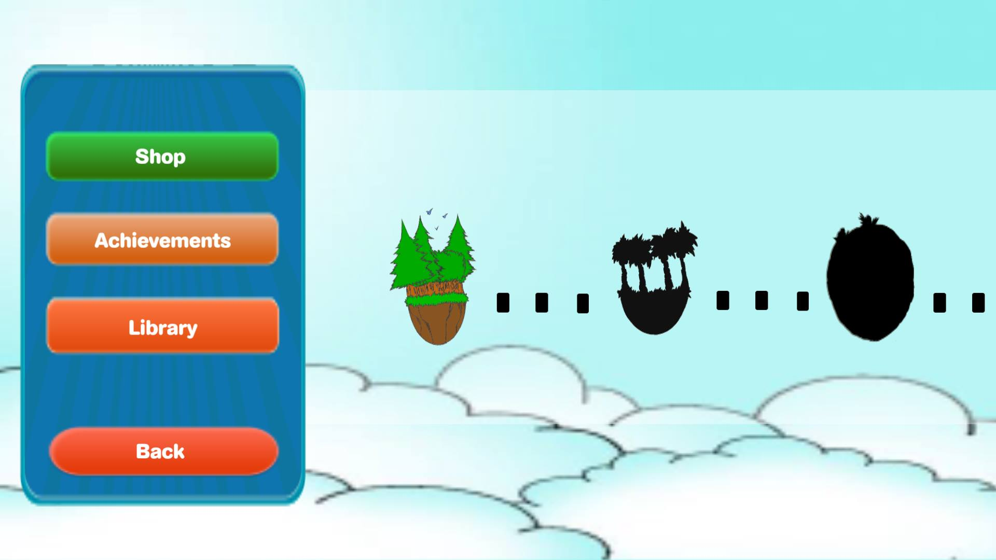

Figure 4. Map

Figure 5 shows the module of each stage, each has 3 different levels which can be unlocked if the user finished the prerequisite level.

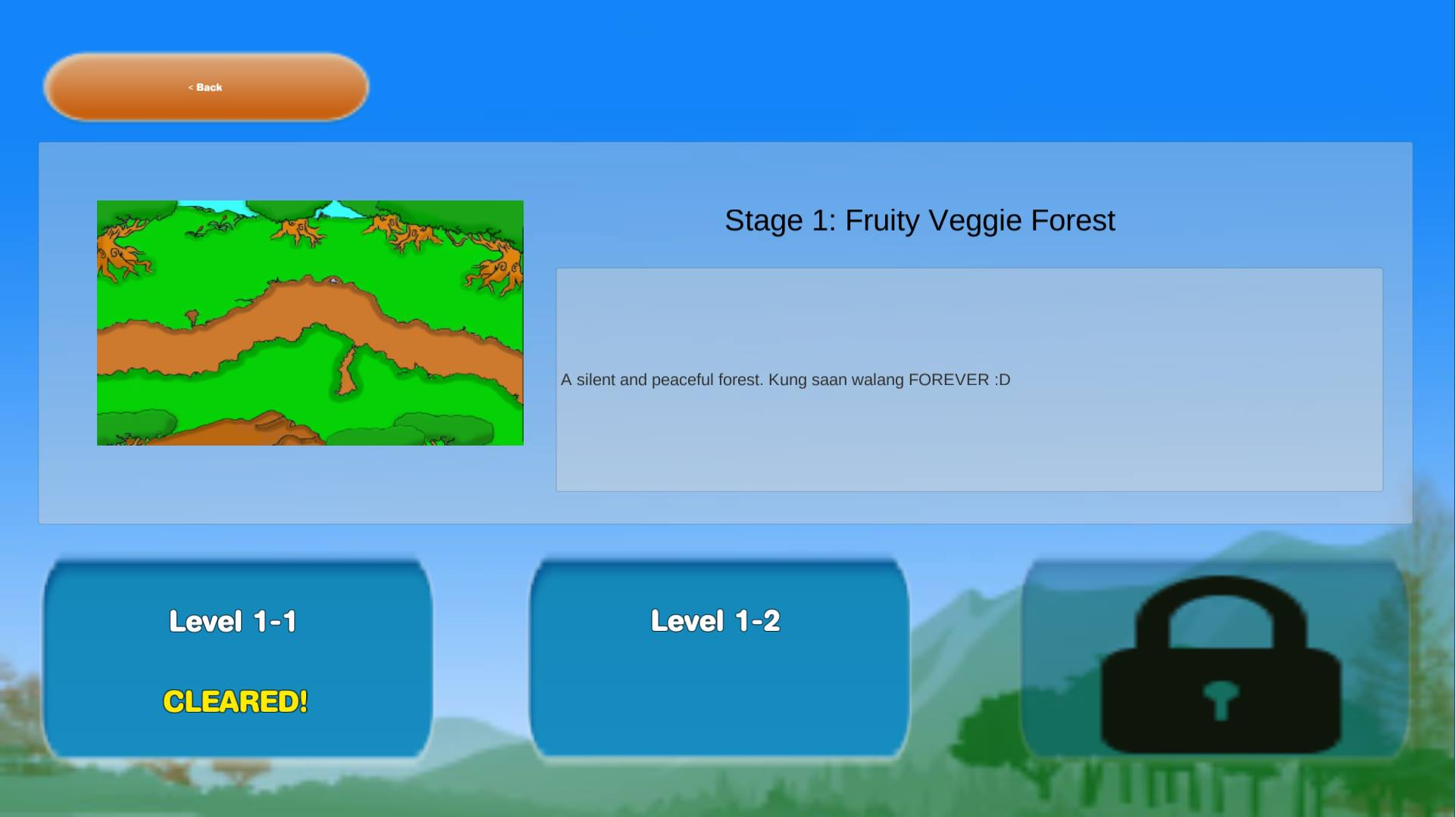

Figure 5. Stage

Figure 6 shows the level, a tutorial shows up when the user first played the game. It shows the fruits and vegetables that you can plant in order to defend fruity veggie world.

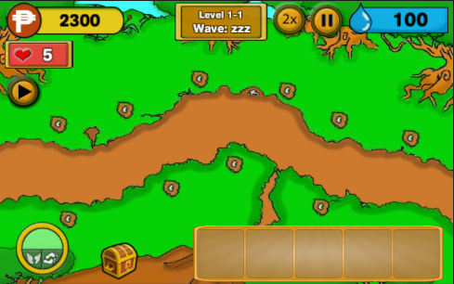

Figure 6. Levels

Figure 7 shows the shop module, In here, the user can upgrade their heroes, buy boosters and special equipments.

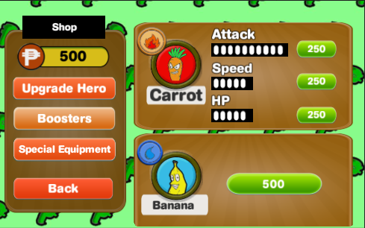

Figure 7. Shop

Figure 8 shows the Library menu, where the information of heroes and insects are recorded.

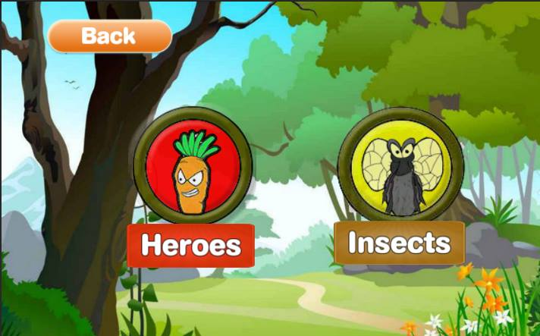

Figure 8. Library

**Project Test Results**

Project tests and results show the behavior of the game during testing.

Table 3 show the testing of the game, behavior of the game in particular testing, and output of the testing if the behavior passed or failed.

|  |  |  |
| --- | --- | --- |
| **TEST** | **BEHAVIOR** | **OUTPUT** |
| Run the game on different android device, with android software specifications of versions 4.2.2 Jellybean and above. | The system runs successfully in different android device with software specifications of versions 4.2.2 Jellybean and above. | **Passed** |

Table 3. Project Testing and Result

**Project Capabilities and Limitations**

The following are the capabilities of the project:

1. The game can run in different android device like Samsung, Lenovo and Cherry Mobile with version 4.2.2 Jellybean and above;

2. The game has friendly graphical user interface;

The following are the limitations of the project:

1. Single User

2. Music and effects are toggle as one.

**Project Evaluation**

The game passes through a series of test to check its functionality, reliability, usability, efficiency, maintainability, and portability. It was implemented for evaluation of 10 chosen Information Technology (IT) experts if it met the set requirements.

Table 4 shows the functionality performance of the game. Functionality performance includes the suitability, accurateness, and interoperability, compliance and security of the game. The grand mean indicates the average mean from the criteria of the functionality performance of the game.

The game got a grand mean of 4.28 which means Very Good in verbal interpretation. This means that the Fruity Veggie Adventure was Very Good in its functionality.

|  |  |  |  |
| --- | --- | --- | --- |
| **FUNCTIONALITY** | **MEAN** | **STANDARD**  **DEVIATION** | **VERBAL**  **INTERPRETATION** |
| Suitability | 4.50 | 0.70 | Very Good |
| Accurateness | 4.50 | 0.70 | Very Good |
| Interoperability | 4.10 | 0.73 | Very Good |
| Compliance | 4.30 | 0.67 | Very Good |
| Security | 4.00 | 0.66 | Very Good |
| **Grand Mean** | **4.28** |  | Very Good |

Table 4. Functionality performance of the game

Table 5 shows the Reliability performance of the game. Reliability performance of the game includes maturity, fault tolerance and recoverability. The grand mean value is the grade of reliability performance of the game.

The reliability performance of game got the grand mean of 4.20 which is equivalent to Very Good in verbal interpretation. This means that the Farmer’s Retribution is reliable

|  |  |  |  |
| --- | --- | --- | --- |
| **RELIABILITY** | **MEAN** | **STANDARD**  **DEVIATION** | **VERBAL**  **INTERPRETATION** |
| Maturity | 4.10 | 0.73 | Very Good |
| Fault Tolerance | 4.10 | 0.73 | Very Good |
| Recoverability | 4.40 | 0.51 | Very Good |
| **Grand Mean** | **4.20** |  | Very Good |

Table 5. Reliability performance of the game

Table 6 shows the usability performance of the game. Usability performance of the game includes understandability, learnability, and operability. The grand mean value of 4.33 was the grade of usability performance of the game.

The usability performance of game got the grand mean of 4.70 which is equivalent to Very Good in verbal interpretation. This means that the Farmer’s Retribution was usable.

|  |  |  |  |
| --- | --- | --- | --- |
| **USABILITY** | **MEAN** | **STANDARD**  **DEVIATION** | **VERBAL**  **INTERPRETATION** |
| Understandability | 4.70 | 0.48 | Very Good |
| Learnability | 4.70 | 0.48 | Very Good |
| Operability | 4.70 | 0.48 | Very Good |
| **Grand Mean** | **4.70** |  | Very Good |

Table 6. Usability performance of the game

Table 7 shows the efficiency performance of the game. Efficiency performance of the game includes time behavior and resource behavior. The grand mean value indicates the grade of efficiency performance of the game.

The efficiency performance of game got the grand mean of 4.20 which is equivalent to Very Good in verbal interpretation. This means that the Farmer’s Retribution was enough working.

|  |  |  |  |
| --- | --- | --- | --- |
| **EFFICIENCY** | **MEAN** | **STANDARD**  **DEVIATION** | **VERBAL**  **INTERPRETATION** |
| Time Behavior | 4.10 | 0.73 | Very Good |
| Resource Behavior | 4.30 | 0.48 | Very Good |
| **Grand Mean** | **4.20** |  | Very Good |

Table 7. Efficiency performance of the game

Table 8 shows the Maintainability performance of the game. Maintainability performance of the game includes analyzability, changeability, stability, and testability. The grand mean value was the grade of maintainability performance of the game.

The maintainability performance of game got the grand mean of 4.23 which is equivalent to Very Good in verbal interpretation. This means that the Farmer’s Retribution can be easily maintained.

|  |  |  |  |
| --- | --- | --- | --- |
| **MAINTAINABILITY** | **MEAN** | **STANDARD**  **DEVIATION** | **VERBAL**  **INTERPRETATION** |
| Analyzability | 4.10 | 0.56 | Very Good |
| Changeability | 3.90 | 0.73 | Very Good |
| Stability | 4.10 | 0.73 | Very Good |
| Testability | 4.80 | 0.42 | Very Good |
| **Grand Mean** | **4.23** |  | Very Good |

Table 8. Maintainability performance of the game

Table 9 shows the Portability performance of the game. Portability performance of the game includes adaptability, install ability, conformance and replace ability. The grand mean value was the grade of portability performance of the game.

The efficiency performance of game got the grand mean of 4.33 which is equivalent to Very Good in verbal interpretation. This means that the Farmer’s Retribution was portable to use.

|  |  |  |  |
| --- | --- | --- | --- |
| **PORTABILITY** | **MEAN** | **STANDARD**  **DEVIATION** | **VERBAL**  **INTERPRETATION** |
| Adaptability | 4.20 | 0.78 | Very Good |
| Installability | 4.70 | 0.48 | Very Good |
| Conformance | 4.30 | 0.67 | Very Good |
| Replaceability | 4.10 | 0.87 | Very Good |
| **Grand Mean** | **4.33** |  | Very Good |

Table 9. Portability performance of the game

Table 10 shows the Overall performance of the game. Overall performance was measured in terms of functionality, reliability, availability, efficiency, maintainability, usability and portability.

The usability obtained the highest mean grade of 4.70 followed by portability and functionality with 4.33 and 4.28 respectively.

Meanwhile, maintainability got a mean grade of 4.23

Then reliability and efficiency got the lowest mean grade of 4.20.

The grand mean of 4.32 rated as very good implies that the game performs well.

Table 10.Over-all performance of the game

|  |  |  |
| --- | --- | --- |
| **CRITERIA** | **MEAN** | **VERBAL**  **INTERPRETATION** |
| Functionality  Reliability  Usability | 4.28  4.20  4.70 | Very Good  Very Good  Very Good |
| Efficiency | 4.20 | Very Good |
| Maintainability | 4.23 | Very Good |
| Portability | 4.33 | Very Good |
| **Grand Mean** | **4.32** | Very Good |

**SUMMARY, CONCLUSION, AND RECOMMENDATION**

This chapter includes summary of findings, conclusions and recommendation of the game.

**Summary**

The developers made the Fruity Veggie Adventure as an android game. It is a game that helps game enthusiast improve their strategic planning. The game has also friendly graphical user interface that match the taste of users of all ages.

The participants found that the game is more portable as the game achieved the overall grand mean of 4.32. It is also found out that the game is usable to use as it achieves the overall grand mean 4.70 which means Very Good in verbal interpretation.

**Conclusion**

In consideration with the objectives of the study and the results of testing and the evaluation carried out, the following conclusions were derived:

1. Fruity Veggie Adventure was installed and performed well in such that:

a. The game can play in three different android devices with android software specifications of versions 4.2.2 Jellybean and above like Samsung, Cherry Mobile and Lenovo;

b. The game can enhance your strategic planning.

c. The game has friendly graphical user interface;

1. The game was successfully created using Unity3d and C# Programming;
2. Test results validated that the game can be used in different android devices with software specifications of versions 4.2.2 Jellybean and above.

**Recommendations**

Implementing the project “Fruity Veggie Adventure” is highly recommended since the game was very enjoyable to play.

Nevertheless, a recommendation to further enhance the functionality of the project is hereby endorsed:

1. Make the game more user friendly.
2. Improve design.
3. Improve graphical user interface.
4. Easy to learn